SQL
Session-2
1.Open MySQL Workbench or CLI and write a CREATE TABLE statement to create a table called 'restaurants' with columns: id (INT, primary key, auto-increment), name (VARCHAR(100)), location (VARCHAR(100)), and rating (DECIMAL(2,1)).
CREATE TABLE restaurants(id INT PRIMARY KEY AUTO_INCREMENT,name VARCHAR(100),location VARCHAR(100),rating DECIMAL(2,1));
Output:
INSERT INTO restaurants (name, location, rating)VALUES('Ramus', 'Vapi Chala Rasta', 4.5),
('Bapus', 'Vapi Station Road', 4.0),('Raju Bhai', 'Vapi Chala Rasta', 4.5),('Gusto', 'Vapi Rajans', 5.0),('Taj Rasto', 'Vapi Daman Road', 5.0);

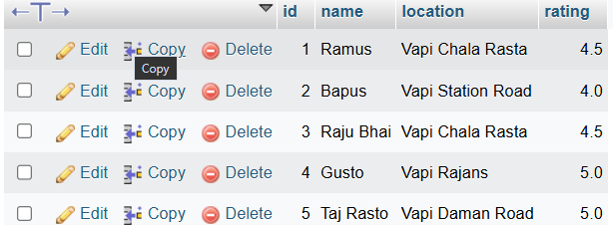
2.Use the ALTER TABLE command in MySQL to add a new column 'average_cost' (INT) to your 'restaurants' table.<br><br><em><strong>Hint:</strong> Remember to specify the data type when adding a new column.</em>
ALTER TABLE restaurants
ADD COLUMN avg_cost INT;
Output:
3.Write a SQL statement to DROP the 'restaurants' table you created earlier. Double-check your command before running it to avoid accidental data loss.
Check:
SELECT * FROM `restaurants`
DROP TABLE restaurants;
Output:
The restaurants table is drop successfully.

4.Create a new table called 'playlists' for a music app like Spotify, with columns: playlist_id (INT, primary key, auto-increment), title (VARCHAR(50)), created_by (VARCHAR(50)), and created_at (DATE).
CREATE TABLE Playlists(playlist_id INT PRIMARY KEY AUTO_INCREMENT,Title VARCHAR(50),created_by VARCHAR(50),created_at DATE);
Output:

